Lent and Holy Week Schedule – 2020 / St. Peter Orthodox Church
Confessions available after every weekday service or by appointment. (rev. 1 / 2020-02-24)

Saturday of the Souls Services
Sat Feb 22 Saturday of the Souls 9:30am
Sat Feb 29 Saturday of the Souls 9:30am

Sunday March 1 Forgiveness / Cheesefare Sunday
Sun Mar 1 Forgiveness Vespers following Divine Liturgy 1:00pm
Mon Mar 2 CLEAN MONDAY / LENT BEGINS
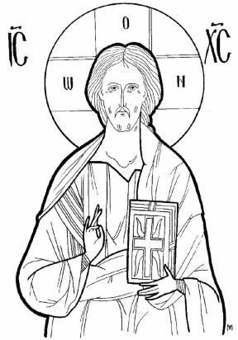
Great Compline with Canon of St. Andrew 6:30pm
Tue Mar 3 Great Compline with Canon of St. Andrew 6:30pm
Wed Mar 4 Presanctified Liturgy 6:30pm
Thu Mar 5 Great Compline with Canon of St. Andrew 6:30pm
Fri Mar 6 First Stanza Salutations 6:30pm

Sunday March 8 Sunday of Orthodoxy
Sun Mar 6 Sunday of Orthodoxy Vespers at St. Paul Naples 5:00pm
Mon Mar 9 Great Compline 6:30pm
Wed Mar 11 Presanctified Liturgy 6:30pm
Fri Mar 13 Second Stanza Salutations 6:30pm
Sat Mar 14 St. Peter/St. Paul Women’s Retreat 9:00am
Sunday March 15 Sunday of St. Gregory Palamas
Mon Mar 16 Great Compline 6:30pm
Wed Mar 18 Presanctified Liturgy 6:30pm
Fri Mar 20 Third Stanza Salutations 6:30pm

Sunday March 22 Sunday of the Veneration of the Cross
Mon Mar 23 Great Compline 6:30pm
Tue Mar 24 Annunciation Vespers 6:30pm
Wed Mar 25 Annunciation Liturgy 9:30am
Fri Mar 27 Fourth Stanza Salutations 6:30pm

Sunday March 29 Sunday of St. John of the Ladder
Mon Mar 30 Great Compline 6:30pm
Wed Apr 1 Presanctified Liturgy 6:30pm
Fri Apr 3 Complete Salutations/Akathist Hymn 6:30pm

Sunday April 5 Sunday of St. Mary of Egypt
Mon Apr 6 Great Compline 6:30pm
Wed Apr 8 Presanctified Liturgy 6:30pm
Fri Apr 10 Small Compline with Canon of St. Lazarus 6:30pm
Sat Apr 11 Lazarus Saturday Liturgy 9:30am / Baptisms / Make crosses / Pancake breakfast / Children confessions – Full Schedule TBA

Holy Week
Sunday April 12 Palm Sunday
Brunch in Social Hall following Divine Liturgy
Bridegroom Service 6:30pm
Mon Apr 13 HOLY MONDAY – Bridegroom Service 6:30pm
Tue Apr 14 HOLY TUESDAY – Bridegroom Service 6:30pm
Wed Apr 15 HOLY WEDNESDAY – Holy Unction 6:30pm
Thu Apr 16 HOLY THURSDAY – Liturgy of the Last Supper 9:30am
Reading of the Twelve Gospels 6:00pm (note earlier time)
Fri Apr 17 HOLY FRIDAY – Royal Hours 9:00am
Decoration of Tomb of Christ 10:30am
Taking Christ Down from the Cross 3:00pm
Lamentations 6:30pm
Sat Apr 18 HOLY SATURDAY – First Resurrection Service 9:30am
Great and Holy Pascha 10:00pm
Sun Apr 19 Agape Vespers 11:00am
Paschal Dinner in Social Hall 1:00pm / Easter egg hunt for children

