Lent and Holy Week Schedule – 2019 / St. Peter Orthodox Church
Confessions available after every weekday service or by appointment. (rev. 8 / 2019-04-03)

Saturday of the Souls Services
Sat Mar 2 Saturday of the Souls 9:30am
Sat Mar 9 CANCELED Saturday of the Souls at St. Paul Orthodox Church (Fr. Hans out of town)
Sat Mar 16 CANCELED Saturday of the Souls (Women’s retreat at St. Paul Orthodox Church)

Sunday March 10 Forgiveness / Cheesefare Sunday
Sun Mar 10 Forgiveness Vespers following General Assembly Meeting
Mon Mar 11 CLEAN MONDAY / LENT BEGINS
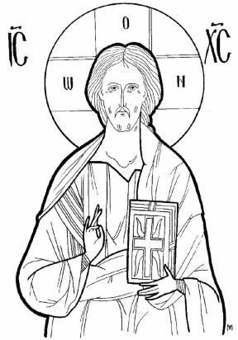
Great Compline with Canon of St. Andrew 6:30pm
Tue Mar 12 Great Compline with Canon of St. Andrew 6:30pm
Wed Mar 13 Presanctified Liturgy 6:30pm
Thu Mar 14 Great Compline with Canon of St. Andrew 6:30pm
Fri Mar 15 First Stanza Salutations 6:30pm
Sat Mar 16 Women’s Retreat at St. Paul’s

Sunday March 17 Sunday of Orthodoxy
Orthodoxy Vespers St. Paul Orthodox Church 5:00pm
Mon Mar 18 Great Compline 6:30pm
Wed Mar 20 Presanctified Liturgy 6:30pm
Fri Mar 22 Second Stanza Salutations 6:30pm
Sunday March 24 Sunday of St. Gregory Palamas
CANCELED Vespers Annunciation at St. Paul’s
Mon Mar 25 Annunciation Liturgy 6:30pm
Wed Mar 27 Presanctified Liturgy 6:30pm
Fri Mar 29 Third Stanza Salutations 5:30pm (note earlier time)

Sunday March 31 Sunday of the Veneration of the Cross
Mon Apr 1 Great Compline 6:30pm
Wed Apr 3 Presanctified Liturgy 6:30pm
Fri Apr 5 Fourth Stanza Salutations 6:30pm

Sunday April 7 Sunday of St. John of the Ladder
Mon Apr 8 Great Compline 6:30pm
Wed Apr 10 Presanctified Liturgy 6:30pm
Fri Apr 12 Complete Salutations 6:30pm

Sunday April 14 Sunday of St. Mary of Egypt
Mon Apr 15 Great Compline 6:30pm
Wed Apr 17 Presanctified Liturgy 6:30pm
Fri Apr 19 Small Compline with Canon of St. Lazarus 6:30pm
Sat Apr 20 Lazarus Saturday Liturgy 9:30am / Baptisms / Make crosses / Pancake breakfast / Children confessions – Full Schedule TBA

Holy Week
Sunday April 21 Palm Sunday
Brunch in Social Hall following Divine Liturgy
Bridegroom Service 6:30pm
Mon Apr 22 HOLY MONDAY – Bridegroom Service 6:30pm
Tue Apr 23 HOLY TUESDAY – Bridegroom Service 6:30pm
Wed Apr 24 HOLY WEDNESDAY – Holy Unction 6:30pm
Thu Apr 25 HOLY THURSDAY – Liturgy of the Last Supper 9:30am
Reading of the Twelve Gospels 6:00pm (note earlier time)
Fri Apr 26 HOLY FRIDAY – Royal Hours 9:00am
Decoration of Tomb of Christ 10:30am
Taking Christ Down from the Cross 3:00pm
Lamentations 6:30pm
Sat Apr 27 HOLY SATURDAY – First Resurrection Service 9:30am
Great and Holy Pascha 10:00pm
Sun Apr 28 Agape Vespers 11:00am
Paschal Dinner in Social Hall 1:00pm / Easter egg hunt for children

