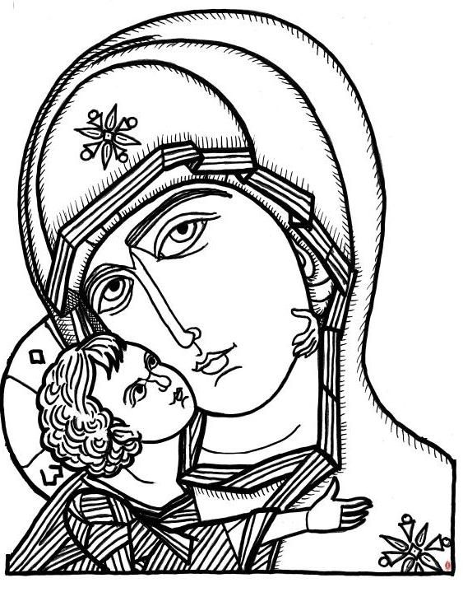

ORTHODOX WOMEN’S LENTEN RETREAT

ST. PETER ORTHODOX CHURCH, SATURDAY, MARCH 3, 2018

“THE THEOTOKOS: A ROLE MODEL FOR WOMEN OF THE 21ST CENTURY”

SCHEDULE:

9:00 – 9:30 REGISTRATION (Coffee and light breakfast)

9:30 – 10:00 Morning Prayers (Clergy)

10:00 –10:45 Lecture: Fr. Johannes Jacobse, “The Theotokos as
Healer: Sometimes It takes a Mother to reveal the Son”

10:45 – 11:00 Q & A

11:00 -- 11:30 BREAKOUT GROUPS

11:30 -- Noon FREE TIME

12:00 – 1:00 LUNCH

1:00 – 1:45 Lecture: Fr. Paul Girgis, “Jesus said: Heal Yourself:
The Theotokos Shows Us How”

1:45 – 2:00 Q & A

2:00 – 2:30 BREAKOUT GROUPS

2:30 – 3:00 EVALUATION AND CONCLUSION

3:00 – 3:30 VESPERS (CLERGY)

REGISTRATION FEE $10:00 TO COVER THE COST OF SUPPLIES, BREAKFAST, LUNCH AND SNACKS.

