Lent and Holy Week Schedule – 2018 / St. Peter Orthodox Church

Confessions available after every weekday service or by appointment. (2018/03/10)

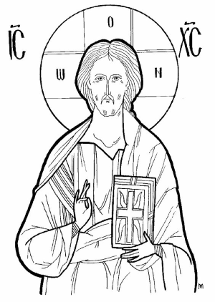
Lent Begins
Mon Feb 19 Great Compline 6:30pm
Tue Feb 20 Great Compline 6:30pm
Wed Feb 21 Presanctified Liturgy 6:30pm
Thu Feb 22 Great Compline 6:30pm
Fri Feb 23 First Stanza Salutations 6:30pm
Sat Feb 24 Saturday of the Souls Liturgy 9:00am

Sunday, February 25 Sunday of Orthodoxy
Vespers at Holy Trinity 5:00pm
Mon Feb 26 Great Compline 6:30pm
Wed Feb 28 Presanctified Liturgy 6:30pm
Fri Mar 2 Second Stanza Salutations 6:30pm
Sat Mar 3 Women’s Retreat 9am
Sunday, March 4 Sunday of St. Gregory Palamas
Mon Mar 5 Great Compline 6:30pm
Wed Mar 7 Presanctified Liturgy 6:30pm
Fri Mar 9 Third Stanza Salutations 6:30pm

Sunday, March 11 Sunday of the Veneration of the Cross
Mon Mar 12 Great Compline 6:30pm
Wed Mar 14 Presanctified Liturgy 6:30pm
Fri Mar 16 Third Stanza Salutations 6:30pm

Sunday, March 19 Sunday of St. John of the Ladder
Mon Mar 19 Great Compline 6:30pm
Wed Mar 21 Presanctified Liturgy 6:30pm
Fri Mar 23 Third Stanza Salutations 6:30pm

Sunday, March 25 Sunday of St. Mary of Egypt / Annunciation of the Theotokos
Mon Mar 26 Great Compline 6:30pm
Wed Mar 28 Presanctified Liturgy 6:30pm
Fri Mar 30 Third Stanza Salutations 6:30pm
Sat Mar 31 Lazarus Saturday Liturgy 9:30am / Make crosses / Pancake breakfast / Children confessions

Holy Week
Sunday, April 1 Palm Sunday / Brunch in Social Hall following
Mon Apr 2 Bridegroom Service 6:30pm
Tue Apr 3 Bridegroom Service 6:30pm
Wed Apr 4 Holy Unction 6:30pm
Thu Apr 5 Liturgy of the Last Supper 9:30am
Reading of the Twelve Gospels 6:30pm
Fri Apr 6 Royal Hours 9:00am / Decoration of Tomb of Christ following
Taking Christ Down from the Cross 3:00pm
Lamentations 6:30pm
Sat Apr 7 First Resurrection Service 9:30am
Great and Holy Pascha 10:00pm
Sun Apr 8 Agape Vespers 11:00am / Paschal Celebration in Social Hall following

